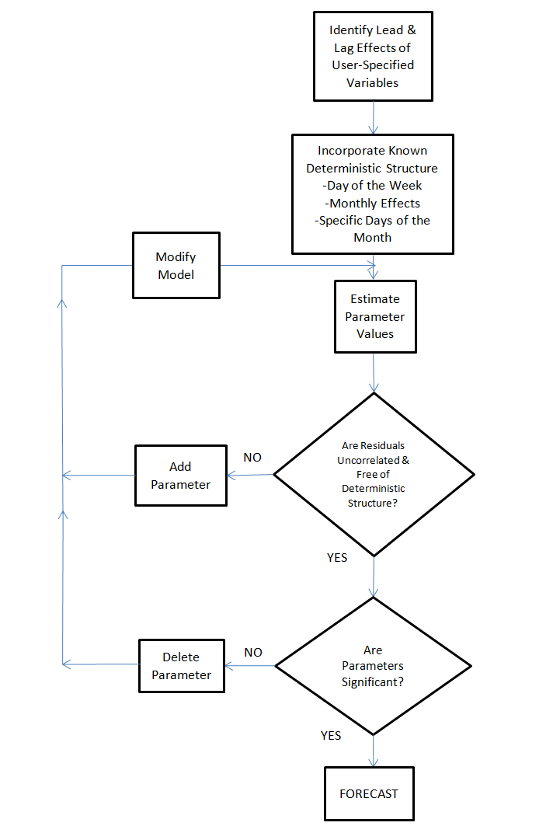

TRANSFER FUNCTION FLOW DIAGRAM